**Clipper 2**

**What is it:**

* Lets you add products to your products page (kind of like “wish list” from amazon) by making a booklet in your bookmarks toolbar
* Self contained js file. Parses all information on the page and pulls in relevant into
* Loads all styles within the clipper.js file
* Pulls in production information from the current page you’re on
* Pulls in the first product if you’re on a product listing page. Or the promotional image of that page

**What it does:**

* You can add a product from any site to any list you create, and pull in information for that product by using the booklet
* Couldn’t test what it does after the product is added to cart since “Add to cart” is broken. Is it supposed to be just a wish list and then you go buy it at other places? (doesn’t work in safari and ff 7)

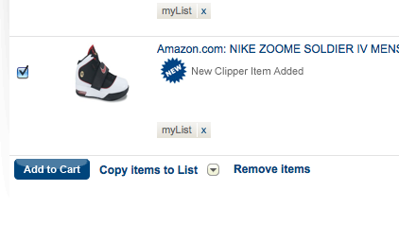

* No difference between Grocery View and List View in “Lists” on mygofer site

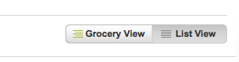

* Step 2 of Product Clipper is broken…?

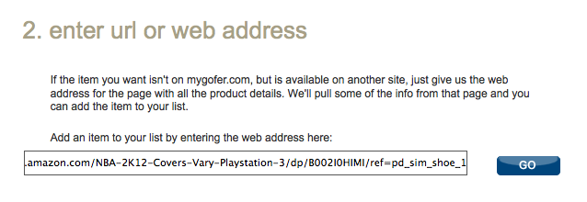

* after this step, it goes to a blank “add product manually” screen

**How we can use it:**

* Allow parents to add gifts and/or presents for birthdays from anywhere
* Allow parents to send out lists, although its been 5 mins and I didn’t get any emails about the list I sent out (nothing in spam folder either). I think having the share link more prominent would be better instead of hiding it away on the right hand side.
* Allows user to quickly add to lists. They can reference later or have it emailed to themselves in case they are out and want a handy reference to remember which items to get